TBSS-LONGLEAF Manual ~

Tengfei Li @ UNC

Nov 24, 2018

1. Login on the department Longleaf cluster. For Windows users, using x-win32 or putty, and connect to the host “longleaf.unc.edu”; for Mac users, open a terminal to type the following command.

ssh username@longleaf.unc.edu

And then type you UNC usrname and password. Install software Winscp or sshClient for windows, or filezilla or cyberduck for Mac. These softwares are for **uploading/downloading** files from longleaf. Install Mango and Mricron software to open images or check the quality.

1. Upload folders step0, step1, step2, step3 to /PATH/ (yourpath) using uploading softwares. Uploading folders ENIGMA_targets, Enigma_ROI_1, enigmaDTI_QC to /PATH/TBSS/. Copy the dataset folder to your own path. Please note that raw images in each subject subfolder of the dataset folder include three files:

data.nii.gz bval bvecs

Next modify the string PATH in step1/FDT_longleaf.m and run it by

cd /PATH/step1/

module load matlab

matlab -nojvm

FDT_longleaf

exit

If it is done, open and check file

/PATH/code/FDT_bat1.pbs

which reads like

“

#!/bin/bash

#SBATCH --ntasks=1

#SBATCH --time=00:59:59

#SBATCH --mem=8000

#SBATCH --wrap=TBSS_1

module load fsl

export FSLDIR=/nas/longleaf/apps/fsl/5.0.9/fsl/

source ${FSLDIR}/etc/fslconf/fsl.sh

export PATH=${FSLDIR}/bin:${PATH}

cd /proj/htzhu/users/tengfei/ABCD_TBSS/data/NDARINVY0RZGBNN

bet data.nii nodif_brain_mask.nii.gz -f .1

dtifit -k data.nii.gz -o dti -m nodif_brain_mask.nii.gz -r bvecs -b bvals

…

”

Then execute the /PATH/code/FDT_batAll.sh file using the following commands to submitpasted-image.tiff all .pbs jobs for all subjects.

“

cd /PATH/code/

chmod 775 FDT_batAll.sh

./FDT_batAll.sh

”

This step will generate all FA, MD, L1, L2, L3, MO images in the folder /PAYH/TBSS. Please make sure all jobs are completed using the Linux command

“qstat -u your-username”. You can also use

qstat –u usrname | grep R –c

to calculate how many jobs are still running, and

qstat –u usrname | grep Q –c

to calculate how many jobs are still pending.

When you are done, please run step1/FDT_longleaf.m again to generate FDT_batAll.sh again. Open FDT_batAll.sh to check if it look like:

“

#!/bin/bash

”

Which means all jobs have been done successfully. Otherwise please run FDT_batAll.sh again until all jobs have been done successfully.

1. Modify the string PATH in step1/Pre_QC_makefile.m, step1/Pre_QC_makeimage.m and step1/Pre_QC_html.m to your specific PATH. (Remember: double check to make sure you save your modification on server; for all the following script files, remember to change your path first before running it). Type the following command at the terminal to run the matlab file step1/Pre_QC_makefile.m.

cd /PATH/step1/

module load matlab

matlab -nojvm

Pre_QC_makefile

exit

This will create a new folder “TBSS/Pre_QC” at /PATH/ and generate the file TBSS/Pre_QC/Subject_Path_Info.txt which gives the path to each individual FA and V1 files.

pasted-image.tiff

4. Type the following command at the terminal to run the matlab file Pre_QC_image.m.

cd /PATH/step1/

module load matlab

matlab -nojvm

Pre_QC_image

exit

If it is done, open and check file

/PATH/code/FDT_bat1.pbs

which reads like

“

#!/bin/bash

#SBATCH --ntasks=1

#SBATCH --time=23:59:59

#SBATCH --mem=8000

#SBATCH --wrap=TBSS_1

module load fsl

module load python/2.7.12

export FSLDIR=/nas/longleaf/apps/fsl/5.0.9/fsl/

source ${FSLDIR}/etc/fslconf/fsl.sh

export PATH=${FSLDIR}/bin:${PATH}

cd /pine/scr/t/e/tengfei/ukbiobank_tbss/code/

module load matlab

for ((i=1;i<=20;i++)); do

matlab -nosplash -nodesktop -r FDT_bat$i>>$i.out

done

”

Then execute the /PATH/code/FDT_batAll.sh file using the following commands to submitpasted-image.tiff all .pbs jobs for all subjects.

“

cd /PATH/code/

chmod 775 FDT_batAll.sh

./FDT_batAll.sh

”

This step will generate all FA quality-control images in the folder /PATH/TBSS/Pre_QC/QC_FA_V1. Please make sure all jobs are completed using the Linux command

“qstat -u your-username”. You can also use

qstat –u usrname | grep R –c

to calculate how many jobs are still running, and

qstat –u usrname | grep Q –c

to calculate how many jobs are still pending. Then check that if the number of .png files inside /PATH/TBSS/Pre_QC/QC_FA_V1 is equal to the total number of subjects.

Next, type the following command at the terminal to run the matlab file Pre_QC_html.m.

cd /PATH/step1/

module load matlab

matlab -nojvm

Pre_QC_html

exit

After Pre_QC_html.m is completed, an .html file

/PATH/TBSS/Pre_QC/QC_FA_V1/index.html

will be generated. Download the folder /PATH/TBSS/Pre_QC/QC_FA_V1/ to your own desktop from longleaf, and open QC_FA_V1/index.html to check thepasted-image.tiff image quality.pasted-image.tiff

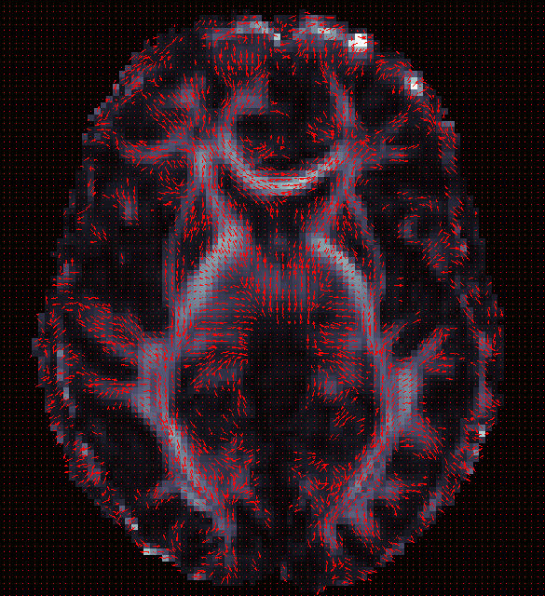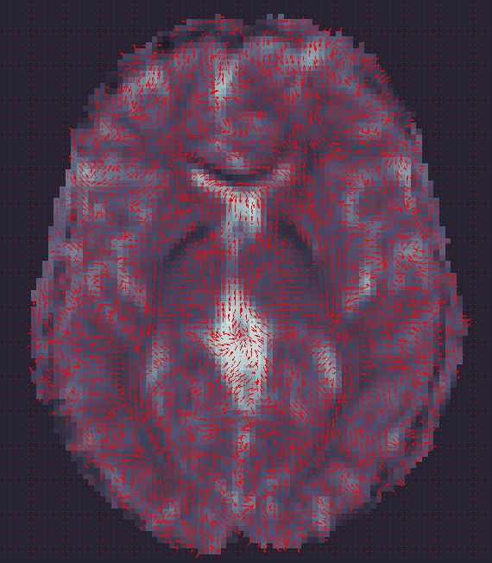

Check the quality of each image in the .html file and make a record of all bad subjects you think in a .txt file.

**5. Preprocessing** **of FA.**

Good bad

**Procedure:**

Type the following command at the terminal to run the matlab file

/Path/step2/FA_TBSS_11.m

“

cd /PATH/step2/

module load matlab

matlab -nojvm

FA_TBSS_11

exit

”

And a new file /Path/code/tbss_1.pbs will be generated which reads like:

“

#!/bin/bash

#SBATCH --ntasks=1

#SBATCH --time=23:59:59

#SBATCH --mem=8000

#SBATCH --wrap=TBSS

module load fsl

module load python/2.7.12

export FSLDIR=/nas/longleaf/apps/fsl/5.0.9/fsl/

source ${FSLDIR}/etc/fslconf/fsl.sh

export PATH=${FSLDIR}/bin:${PATH}

mkdir /pine/scr/t/e/tengfei/ukbiobank_tbss/TBSS/FAtbss

cp /pine/scr/t/e/tengfei/ukbiobank_tbss/TBSS/FA/*_FA.nii.gz /pine/scr/t/e/tengfei/ukbiobank_tbss/TBSS/FAtbss/

cd /pine/scr/t/e/tengfei/ukbiobank_tbss/TBSS/FAtbss

tbss_1_preproc *.nii.gz

mkdir /pine/scr/t/e/tengfei/ukbiobank_tbss/TBSS/FAtbss/FA2ENIGMAtemplate

cp /pine/scr/t/e/tengfei/ukbiobank_tbss/TBSS/FAtbss/FA/*_FA_FA.nii.gz /pine/scr/t/e/tengfei/ukbiobank_tbss/TBSS/FAtbss/FA2ENIGMAtemplate

“

Submit /Path/code/tbss_1.pbs by using

cd /Path/code/

qsub tbss_1.pbs

And make sure it runs sucessfully. When it is completed, new folders

/PATH/TBSS/FAtbss;/PATH/TBSS/FAtbss/FA;/PATH/TBSS/FAtbss/FA2ENIGMAtemplate

will be generated; files

/PATH/TBSS/FAtbss/FA/SubID/SubID_FA_FA.nii.gz

/PATH/TBSS/FAtbss/FA/SubID/SubID_FA_FA_mask.nii.gz

will be generated. SubID_FA_FA.nii.gz is the preprocessed FA.

Original FA Preprocessed FA

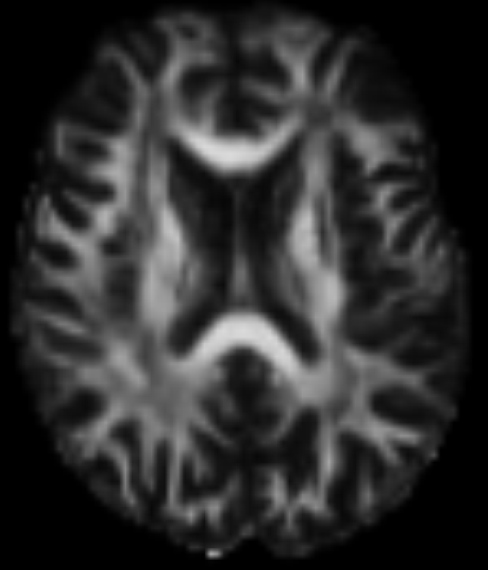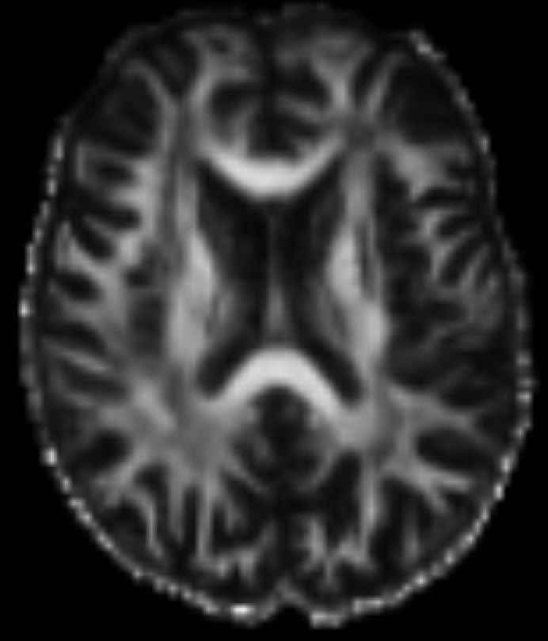

**6.** **Run Linear registration.**

Type the following command at the terminal to run the matlab file

/Path/step2/FA_TBSS_12.m

“

cd /PATH/step2/

module load matlab

matlab -nojvm

FA_TBSS_12

exit

”

And new files such as /Path/code/tbss_1_1.pbs will be generated which reads like:

“

#!/bin/bash

#SBATCH --ntasks=1

#SBATCH --time=01:59:59

#SBATCH --mem=8000

#SBATCH --wrap=TBSS_1

module load fsl

module load python/2.7.12

export FSLDIR=/nas/longleaf/apps/fsl/5.0.9/fsl/

source ${FSLDIR}/etc/fslconf/fsl.sh

export PATH=${FSLDIR}/bin:${PATH}

cd /pine/scr/t/e/tengfei/ukbiobank_tbss/TBSS/FAtbss

flirt -in ./FA2ENIGMAtemplate/6002122_FA_FA.nii.gz -ref /pine/scr/t/e/tengfei/ukbiobank_tbss/TBSS/ENIGMA_targets/ENIGMA_DTI_FA.nii.gz -out ./FA2ENIGMAtemplate/6002122_FA_to_target.nii.gz -omat ./FA2ENIGMAtemplate/6002122_FA_to_target.mat -dof 9

…

”

Then execute the /PATH/code/tbss_1T.sh file using the following commands to submit all .pbs jobs for all subjects.

“

cd /PATH/code/

chmod 775 tbss_1T.sh

./tbss_1T.sh

”

This step will linearly register all preprocessed FA images

/PATH/TBSS/FAtbss/FA/SubID/SubID_FA_FA.nii.gz

to FA template /PATH/TBSS/ENIGMA_targets/ENIGMA_DTI_FA.nii.gz. Please make sure all jobs are completed using the Linux command “qstat -u your-username”. Then repeat this step by running the matlab file FA_TBSS_12.m again, until /Path/code/tbss_1T.sh reads like:

“

#!/bin/bash

”

Then all subjects have been successfully registered to the ENIGMA_DTI_FA.nii.gz.

The output (registered FA images and linear transformation matrix) are

/PATH/TBSS/FAtbss/FA2ENIGMAtemplate/SubID_FA_to_target.nii.gz

/PATH/TBSS/FAtbss/FA2ENIGMAtemplate/SubID_FA_to_target.matpasted-image.tiffpasted-image.tiff

Template: ENIGMA_DTI_FA.nii.gz SubID_FA_to_target.nii.gz SubID_FA_to_target.nii.gz

**7. Quality control of the linear registration**

Type the following command at the terminal to run the matlab file

/Path/step2/FA_TBSS_13.m

“

cd /PATH/step2/

module load matlab

matlab -nojvm

FA_TBSS_13

exit

”

And a new file /Path/code/tbss_13.sh will be generated which reads like:

“

#!/bin/bash

module load fsl

module load python/2.7.12

export FSLDIR=/nas/longleaf/apps/fsl/5.0.9/fsl/

source ${FSLDIR}/etc/fslconf/fsl.sh

export PATH=${FSLDIR}/bin:${PATH}

mkdir /pine/scr/t/e/tengfei/ukbiobank_tbss/TBSS/FAtbss/QC_Reg

cd /pine/scr/t/e/tengfei/ukbiobank_tbss/TBSS/FAtbss

cp ./FA2ENIGMAtemplate/*_FA_to_target.nii.gz ./QC_Reg

cd /pine/scr/t/e/tengfei/ukbiobank_tbss/TBSS/FAtbss/QC_Reg/

$FSLDIR/bin/slicesdir `$FSLDIR/bin/imglob *_FA_to_target.*` > grot 2>&1

cat grot | tail -n 2

/bin/rm grot

”

Then execute the /PATH/code/tbss_13.sh using:

“cd /PATH/code/

sh tbss_13.sh”

The html folder for quality control will be generated at:

/PATH/TBSS/FAtbss/QC_Reg/slicesdir/index.html

Download the folder /PATH/TBSS/FAtbss/QC_Reg/slicesdir/ to your own desktop and open index.html to roughly check the registered image quality.pasted-image.tiff

**7. Nonlinear registration of FA image**

Type the following command at the terminal to run the matlab file

/Path/step2/FA_TBSS_2_and_3.m

“

cd /PATH/step2/

module load matlab

matlab -nojvm

FA_TBSS_2_and_3

exit

”

And new files such as /Path/code/tbss_23_1.pbs will be generated which reads like:

“

#!/bin/bash

#SBATCH --ntasks=1

#SBATCH --time=01:59:59

#SBATCH --mem=8000

#SBATCH --wrap=TBSS_1

module load fsl

module load python/2.7.12

export FSLDIR=/nas/longleaf/apps/fsl/5.0.9/fsl/

source ${FSLDIR}/etc/fslconf/fsl.sh

export PATH=${FSLDIR}/bin:${PATH}

cd /pine/scr/t/e/tengfei/ukbiobank_tbss/TBSS/FAtbss

mkdir -p ./FA_individ/6002122/stats/

mkdir -p ./FA_individ/6002122/FA/

cp ./FA/6002122_*.nii.gz ./FA_individ/6002122/FA/

cd /pine/scr/t/e/tengfei/ukbiobank_tbss/TBSS/FAtbss/FA_individ/6002122

fsl_reg ./FA/6002122_FA_FA.nii.gz /pine/scr/t/e/tengfei/ukbiobank_tbss//TBSS/ENIGMA_targets/ENIGMA_DTI_FA.nii.gz ./FA/6002122_FA_FA_to_target -FA

cp /pine/scr/t/e/tengfei/ukbiobank_tbss/TBSS/ENIGMA_targets/ENIGMA_DTI_FA.nii.gz ./FA/target.nii.gz

tbss_3_postreg -S

rm ./FA/6002122_FA_to_target.nii.gz

${FSLDIR}/bin/fslmaths ./FA/6002122*_FA_to_target.nii.gz -mas /pine/scr/t/e/tengfei/ukbiobank_tbss/TBSS/ENIGMA_targets/ENIGMA_DTI_FA_mask.nii.gz ./FA/6002122_masked_FA.nii.gz

cp ./FA/6002122_masked_FA.nii.gz /pine/scr/t/e/tengfei/ukbiobank_tbss/TBSS/FAtbss/FA/

${FSLDIR}/bin/tbss_skeleton -i ./FA/6002122_masked_FA.nii.gz -p 0.049 /pine/scr/t/e/tengfei/ukbiobank_tbss/TBSS/ENIGMA_targets/ENIGMA_DTI_FA_skeleton_mask_dst ${FSLDIR}/data/standard/LowerCingulum_1mm.nii.gz ./FA/6002122_masked_FA.nii.gz ./stats/6002122_masked_FAskel.nii.gz -s /pine/scr/t/e/tengfei/ukbiobank_tbss/TBSS/ENIGMA_targets/ENIGMA_DTI_FA_skeleton_mask.nii.gz

…

”

Then execute the /PATH/code/tbss_23_all.sh file using the following commands to submit all .pbs jobs for all subjects.

“

cd /PATH/code/

chmod 775 tbss_23_all.sh

./tbss_23_all.sh

”

This step will **nonlinearly** register all preprocessed FA images

/PATH/TBSS/FAtbss/FA/SubID/SubID_FA_FA.nii.gz

to FA template /PATH/TBSS/ENIGMA_targets/ENIGMA_DTI_FA.nii.gz and project them to the TBSS skeleton /PATH/TBSS/ENIGMA_targets/ENIGMA_DTI_FA_skeleton.nii.gz. Please make sure all jobs are completed using the Linux command “qstat -u your-username”. Then repeat this step by running the matlab file FA_TBSS_2_and_3.m again, until /Path/code/tbss_23_all.sh reads like:

“

#!/bin/bash

”

Then all subjects have been successfully registered to the ENIGMA_DTI_FA.nii.gz.

The output (registered FA images, skeletonize images, and nonlinear warping fields) are

/PATH/TBSS/FAtbss/FA/SubID_masked_FA.nii.gz

/PATH/TBSS/FAtbss/FA_individ/SubID/stats/SubID__masked_FAskel.nii.gz

/PATH/TBSS/FAtbss/FA_individ/SubID/FA/SubID_FA_FA_to_target_warp.nii.gzpasted-image.tiffpasted-image.tiff

SubID_masked_FA.nii.gz SubID__masked_FAskel.nii.gz

**8**. **Quality control and and summarization of the nonlinear registration**

Type the following command at the terminal to run the .sh file

/Path/step3/png1.sh

“

cd /PATH/step3/

sh png1.sh

”

This will create the folder /Path/TBSS/FAtbss/FA/slicedir and the .html file

/Path/TBSS/FAtbss/FA/slicedir/index.html

Copy the folder /Path/TBSS/FAtbss/FA/slicedir to your own desktop and open

index.html to roughly check the registered image quality.pasted-image.tiff

You can see that the nonlinearly registered results are aligned much better comparing with Step 6.

Next, type the following command at the terminal to run the matlab file

/Path/step3/FA_ROI_1_avg_nautilus.m

“

cd /PATH/step3/

module load matlab

matlab -nojvm

FA_ROI_1_avg_nautilus

exit

”

A new .sh file will be generated /PATH/code/FA_ROI_1_avg.sh. Then type the following command at the terminal to run the .sh file /PATH/code/FA_ROI_1_avg.sh

“

cd /PATH/code/

sh FA_ROI_1_avg.sh

”

Then the ROI-based summary statistics .csv files avg_SubID_ROIout.csv will be generated in

/PATH/TBSS/Enigma_ROI_1

which reads likepasted-image.tiff

9. **Register L1/L2/L3/MD/MO/S0**

Type the following command at the terminal to run the matlab file

/Path/step3/MD1.m

“

cd /PATH/step3/

module load matlab

matlab -nojvm

MD1

exit

”

And new files such as /Path/code/FS_bat1.pbs will be generated which reads like:

“

#!/bin/bash

#SBATCH --ntasks=1

#SBATCH --time=10:00:00

#SBATCH --mem=8000

#SBATCH --wrap=TBSS_1

module load fsl

module load python/2.7.12

export FSLDIR=/nas/longleaf/apps/fsl/5.0.9/fsl/

source ${FSLDIR}/etc/fslconf/fsl.sh

export PATH=${FSLDIR}/bin:${PATH}

export ENIGMAtemplateDirectory=/pine/scr/t/e/tengfei/ukbiobank_tbss/TBSS/ENIGMA_targets

export parentDirectory=/pine/scr/t/e/tengfei/ukbiobank_tbss/TBSS/FAtbss

export dtifit_folder=/pine/scr/t/e/tengfei/ukbiobank_tbss/TBSS

cd /pine/scr/t/e/tengfei/ukbiobank_tbss/TBSS/FAtbss

cp /pine/scr/t/e/tengfei/ukbiobank_tbss/TBSS/MD/6007521_MD.nii.gz /pine/scr/t/e/tengfei/ukbiobank_tbss/TBSS/FAtbss/MD/6007521_MD.nii.gz

cp /pine/scr/t/e/tengfei/ukbiobank_tbss/TBSS/L1/6007521_L1.nii.gz /pine/scr/t/e/tengfei/ukbiobank_tbss/TBSS/FAtbss/L1/6007521_L1.nii.gz

cp /pine/scr/t/e/tengfei/ukbiobank_tbss/TBSS/L2/6007521_L2.nii.gz /pine/scr/t/e/tengfei/ukbiobank_tbss/TBSS/FAtbss/L2/6007521_L2.nii.gz

cp /pine/scr/t/e/tengfei/ukbiobank_tbss/TBSS/L3/6007521_L3.nii.gz /pine/scr/t/e/tengfei/ukbiobank_tbss/TBSS/FAtbss/L3/6007521_L3.nii.gz

cp /pine/scr/t/e/tengfei/ukbiobank_tbss/TBSS/MO/6007521_MO.nii.gz /pine/scr/t/e/tengfei/ukbiobank_tbss/TBSS/FAtbss/MO/6007521_MO.nii.gz

cp /pine/scr/t/e/tengfei/ukbiobank_tbss/TBSS/S0/6007521_S0.nii.gz /pine/scr/t/e/tengfei/ukbiobank_tbss/TBSS/FAtbss/S0/6007521_S0.nii.gz

mkdir -p /pine/scr/t/e/tengfei/ukbiobank_tbss/TBSS/FAtbss/MD/origdata/

mkdir -p /pine/scr/t/e/tengfei/ukbiobank_tbss/TBSS/FAtbss/MD_individ/6007521/MD

mkdir -p /pine/scr/t/e/tengfei/ukbiobank_tbss/TBSS/FAtbss/MD_individ/6007521/stats/

/nas/longleaf/apps/fsl/5.0.9/fsl//bin/fslmaths /pine/scr/t/e/tengfei/ukbiobank_tbss/TBSS/FAtbss/MD/6007521_MD.nii.gz -mas /pine/scr/t/e/tengfei/ukbiobank_tbss/TBSS/FAtbss/FA/6007521_FA_FA_mask.nii.gz /pine/scr/t/e/tengfei/ukbiobank_tbss/TBSS/FAtbss/MD_individ/6007521/MD/6007521_MD

/nas/longleaf/apps/fsl/5.0.9/fsl//bin/immv /pine/scr/t/e/tengfei/ukbiobank_tbss/TBSS/FAtbss/MD/6007521 /pine/scr/t/e/tengfei/ukbiobank_tbss/TBSS/FAtbss/MD/origdata

/nas/longleaf/apps/fsl/5.0.9/fsl//bin/applywarp -i /pine/scr/t/e/tengfei/ukbiobank_tbss/TBSS/FAtbss/MD_individ/6007521/MD/6007521_MD -o /pine/scr/t/e/tengfei/ukbiobank_tbss/TBSS/FAtbss/MD_individ/6007521/MD/6007521_MD_to_target -r /nas/longleaf/apps/fsl/5.0.9/fsl//data/standard/FMRIB58_FA_1mm -w /pine/scr/t/e/tengfei/ukbiobank_tbss/TBSS/FAtbss/FA_individ/6007521/FA/6007521_FA_FA_to_target_warp.nii.gz

/nas/longleaf/apps/fsl/5.0.9/fsl//bin/fslmaths /pine/scr/t/e/tengfei/ukbiobank_tbss/TBSS/FAtbss/MD_individ/6007521/MD/6007521_MD_to_target -mas /pine/scr/t/e/tengfei/ukbiobank_tbss/TBSS/ENIGMA_targets/ENIGMA_DTI_FA_mask.nii.gz /pine/scr/t/e/tengfei/ukbiobank_tbss/TBSS/FAtbss/MD_individ/6007521/MD/6007521_masked_MD.nii.gz

/nas/longleaf/apps/fsl/5.0.9/fsl//bin/tbss_skeleton -i /pine/scr/t/e/tengfei/ukbiobank_tbss/TBSS/ENIGMA_targets/ENIGMA_DTI_FA.nii.gz -p 0.049 /pine/scr/t/e/tengfei/ukbiobank_tbss/TBSS/ENIGMA_targets/ENIGMA_DTI_FA_skeleton_mask_dst.nii.gz /nas/longleaf/apps/fsl/5.0.9/fsl//data/standard/LowerCingulum_1mm.nii.gz /pine/scr/t/e/tengfei/ukbiobank_tbss/TBSS/FAtbss/FA_individ/6007521/FA/6007521_masked_FA.nii.gz /pine/scr/t/e/tengfei/ukbiobank_tbss/TBSS/FAtbss/MD_individ/6007521/stats/6007521_masked_MDskel -a /pine/scr/t/e/tengfei/ukbiobank_tbss/TBSS/FAtbss/MD_individ/6007521/MD/6007521_masked_MD.nii.gz -s /pine/scr/t/e/tengfei/ukbiobank_tbss/TBSS/ENIGMA_targets/ENIGMA_DTI_FA_skeleton_mask.nii.gz …

”

Then execute the /PATH/code/FS_batAll.sh file using the following commands to submit all .pbs jobs for all subjects.

“

cd /PATH/code/

chmod 775 FS_batAll.sh

./FS_batAll.sh

”

In this step we will transfer all MD/MO/S0/L1/L2/L3 images from subject space to template space and skeletonize them to the TBSS skeleton. The output will be

/PATH/TBSS/FAtbss/MD_individ/SubID/MD/SubID_masked_MD.nii.gz

/PATH/TBSS/FAtbss/S0_individ/SubID/S0/SubID_masked_S0.nii.gz

/PATH/TBSS/FAtbss/MO_individ/SubID/MO/SubID_masked_MO.nii.gz

/PATH/TBSS/FAtbss/L1_individ/SubID/L1/SubID_masked_L1.nii.gz

/PATH/TBSS/FAtbss/L2_individ/SubID/L2/SubID_masked_L2.nii.gz

/PATH/TBSS/FAtbss/L3_individ/SubID/L3/SubID_masked_L3.nii.gz

/PATH/TBSS/FAtbss/MD_individ/SubID/stats/SubID_masked_MDskel.nii.gz

/PATH/TBSS/FAtbss/S0_individ/SubID/stats/SubID_masked_S0skel.nii.gz

/PATH/TBSS/FAtbss/MO_individ/SubID/stats/SubID_masked_MOskel.nii.gz

/PATH/TBSS/FAtbss/L1_individ/SubID/stats/SubID_masked_L1skel.nii.gz

/PATH/TBSS/FAtbss/L2_individ/SubID/stats/SubID_masked_L2skel.nii.gz

/PATH/TBSS/FAtbss/L3_individ/SubID/stats/SubID_masked_L3skel.nii.gz

**10**. **Summary all results**

Next, type the following command at the terminal to run the matlab file

/Path/step3/MD2.m

“

cd /PATH/step3/

module load matlab

matlab -nojvm

MD2

exit

”

And new files such as /Path/code/FS_bat1.pbs will be generated which reads like:

“

#!/bin/bash

#SBATCH --ntasks=1

#SBATCH --time=01:00:0

#SBATCH --mem=8000

#SBATCH --wrap=TBSS_1

module load fsl

module load python/2.7.12

export FSLDIR=/nas/longleaf/apps/fsl/5.0.9/fsl/

source ${FSLDIR}/etc/fslconf/fsl.sh

export PATH=${FSLDIR}/bin:${PATH}

export ENIGMAtemplateDirectory=/pine/scr/t/e/tengfei/ukbiobank_tbss/TBSS/ENIGMA_targets

export parentDirectory=/pine/scr/t/e/tengfei/ukbiobank_tbss/TBSS/FAtbss

export dtifit_folder=/pine/scr/t/e/tengfei/ukbiobank_tbss/TBSS

export runDirectory=/pine/scr/t/e/tengfei/ukbiobank_tbss/TBSS/Enigma_ROI_1

export dirO1=/pine/scr/t/e/tengfei/ukbiobank_tbss/TBSS/FAtbss/MD_individ/MD_ENIGMA_ROI_part1/

export dirO2=/pine/scr/t/e/tengfei/ukbiobank_tbss/TBSS/FAtbss/MD_individ/MD_ENIGMA_ROI_part2/

/pine/scr/t/e/tengfei/ukbiobank_tbss/TBSS/Enigma_ROI_1/singleSubjROI_exe /pine/scr/t/e/tengfei/ukbiobank_tbss/TBSS/Enigma_ROI_1/ENIGMA_look_up_table.txt /pine/scr/t/e/tengfei/ukbiobank_tbss/TBSS/Enigma_ROI_1/mean_FA_skeleton.nii.gz /pine/scr/t/e/tengfei/ukbiobank_tbss/TBSS/Enigma_ROI_1/JHU-WhiteMatter-labels-1mm.nii.gz /pine/scr/t/e/tengfei/ukbiobank_tbss/TBSS/FAtbss/MD_individ/MD_ENIGMA_ROI_part1//6007521_MD_ROIout /pine/scr/t/e/tengfei/ukbiobank_tbss/TBSS/FAtbss/MD_individ/6007521/stats/6007521_masked_MDskel.nii.gz

/pine/scr/t/e/tengfei/ukbiobank_tbss/TBSS/Enigma_ROI_1/averageSubjectTracts_exe /pine/scr/t/e/tengfei/ukbiobank_tbss/TBSS/FAtbss/MD_individ/MD_ENIGMA_ROI_part1//6007521_MD_ROIout.csv /pine/scr/t/e/tengfei/ukbiobank_tbss/TBSS/FAtbss/MD_individ/MD_ENIGMA_ROI_part2//6007521_MD_ROIout_avg.csv

…

”

Then execute the /PATH/code/FS_batAll.sh file using the following commands to submit all .pbs jobs for all subjects.

“

cd /PATH/code/

chmod 775 FS_batAll.sh

./FS_batAll.sh

”

This will create csv files in

/Path/TBSS/FAtbss/MD_individ/MD_ENIGMA_ROI_part2

/Path/TBSS/FAtbss/MO_individ/MO_ENIGMA_ROI_part2

/Path/TBSS/FAtbss/S0_individ/S0_ENIGMA_ROI_part2

/Path/TBSS/FAtbss/L1_individ/L1_ENIGMA_ROI_part2

/Path/TBSS/FAtbss/L2_individ/L2_ENIGMA_ROI_part2

/Path/TBSS/FAtbss/L3_individ/L3_ENIGMA_ROI_part2

which summarize the ROI-based statistics. Each csv file reads like:pasted-image.tiff

Finally, run /Path/step3/summ.r using the following commands:

“

cd /PATH/step3/

module load r

R CMD BATCH summ.r

”

Then the folder /Path/TBSS/FAtbss/tosave will be generated, ROI results will be summarized in:

/Path/TBSS/FAtbss/tosave/FA_ROIavg.csv

/Path/TBSS/FAtbss/tosave/MD_ROIavg.csv

/Path/TBSS/FAtbss/tosave/MO_ROIavg.csv

/Path/TBSS/FAtbss/tosave/S0_ROIavg.csv

/Path/TBSS/FAtbss/tosave/L1_ROIavg.csv

/Path/TBSS/FAtbss/tosave/L2_ROIavg.csv

/Path/TBSS/FAtbss/tosave/L3_ROIavg.csv

All nonlinearly registered and skeletonized images as well as linear transformation matrix and nonlinear warping fields will be copied to /Path/TBSS/FAtbss/tosave.

Output:

/Path/TBSS/FAtbss/tosave/FA_ROIavg.csv

/Path/TBSS/FAtbss/tosave/MD_ROIavg.csv

/Path/TBSS/FAtbss/tosave/MO_ROIavg.csv

/Path/TBSS/FAtbss/tosave/S0_ROIavg.csv

/Path/TBSS/FAtbss/tosave/L1_ROIavg.csv

/Path/TBSS/FAtbss/tosave/L2_ROIavg.csv

/Path/TBSS/FAtbss/tosave/L3_ROIavg.csv

/Path/TBSS/FAtbss/tosave/SubID_masked_FAskel.nii.gz/

/Path/TBSS/FAtbss/tosave/SubID_masked_MDskel.nii.gz/

/Path/TBSS/FAtbss/tosave/SubID_masked_MOskel.nii.gz/

/Path/TBSS/FAtbss/tosave/SubID_masked_S0skel.nii.gz/

/Path/TBSS/FAtbss/tosave/SubID_masked_L1skel.nii.gz/

/Path/TBSS/FAtbss/tosave/SubID_masked_L2skel.nii.gz/

/Path/TBSS/FAtbss/tosave/SubID_masked_L3skel.nii.gz/

/Path/TBSS/FAtbss/tosave/SubID_masked_MD.nii.gz/

/Path/TBSS/FAtbss/tosave/SubID_masked_MO.nii.gz/

/Path/TBSS/FAtbss/tosave/SubID_masked_S0.nii.gz/

/Path/TBSS/FAtbss/tosave/SubID_masked_L1.nii.gz/

/Path/TBSS/FAtbss/tosave/SubID_masked_L2.nii.gz/

/Path/TBSS/FAtbss/tosave/SubID_masked_L3.nii.gz/

Check if FA_ROIavg.csv is 63 columns (ROIs) and n rows.

You are done here!

**Appendix:**

**Workflow**

pasted-image.tiff